

**CAPSTONE PROPOSAL**

**DOG BREED CLASSIFICATION**

By:

QASIM HASSAN

OBJECTIVE:

The objective for this proposal is to classify different type of dog breed.

BACKGROUND:

Image classification is an important and growing domain of Machine Learning yet it is also one of the most challenging and CPU intensive process. But then Convolutional Neural Network has grown out to be a useful tool for such CPU intensive task. One of the first model that has given CNN a wide scale recognition was **Alexnet** [1].

# PROJECT TASK:

In this project task I am going to code an algorithm to identify the breed of dog in the provided dog image. To do this we are going to perform test on 02 algorithms one of which is to be built from scratch and other one will be any suitable model from PyTorch model zoo. In the last we will also check if a human image is provided then it will predict the closely matching dog breed relative to that human. Face detection will be done with the help of OpenCV.

# DATA SETS & INPUT:

There are two data sets provide, one for human and other for dog that can be accessed with the link below:

* [Dog Dataset](https://s3-us-west-1.amazonaws.com/udacity-aind/dog-project/dogImages.zip)
* [Human Dataset](https://s3-us-west-1.amazonaws.com/udacity-aind/dog-project/lfw.zip).

Dog Dataset contains 8351 images of 133 dog breed of which 6680 is allocated for training while 835 and 836 is allocated for validation and testing respectively. On the other hand, human dataset contains 13,233 human images. Below is the summary of the provided dog data set for which a CNN model is created:

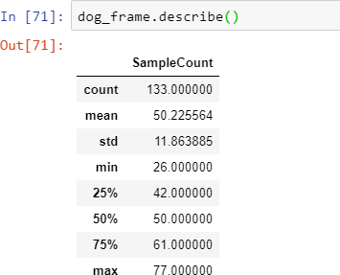

Fig: 1

From the statistical point of view the dataset looks pretty balanced.

# SOLUTION STATEMENT:

The solution is to create a CNN model to maximize the test set accuracy i.e. model should be able to identify the breed of dog with maximum accuracy.

# PROPOSED MODEL:

## Custom CNN:

I have decided to create a five layered CNN model approached with a Max Pooling layer after each Convolution layer in a sandwiched manner. The output will be fed to the two fully connected layers that will eventually predict “1” in any of the 133 dog breeds. Dog detection will be assisted via pre-trained VGG16 model.

## Benchmark Model:

I am then going to compare my custom model with the restnet50, which is exceptionally good in image recognition. Model will be trained further on already learned parameter via transfer learning methodology.

Furthermore, the best performing model will be tested on the random images of human and dogs and the model will predict the best matching breed for each of the fed images.

# Evaluation Metrics:

Model will be evaluated based on the test set accuracy, i.e. how accurately is it able to identify the dog breed. It is given that custom built CNN must achieve an accuracy of 10% while the pre-trained benchmark trained further using transfer learning must achieve at least 60% accuracy.

# Project Design:

The project is organized in following manner:

* Dataset exploration (Cleaning, & Preprocessing)

1. Detect Humans using OpenCV Haar Feature Based Cascade Classifier
2. Detect Dogs using pre-trained VGG16

* Create a CNN to Classify Dog Breeds (from Scratch)
* Create a CNN to Classify Dog Breeds (using Transfer Learning)
* Writing Algorithm
* Testing & evaluating Algorithm based on the test set accuracy.

Generally, the workflow will follow the general schematic as shown below.

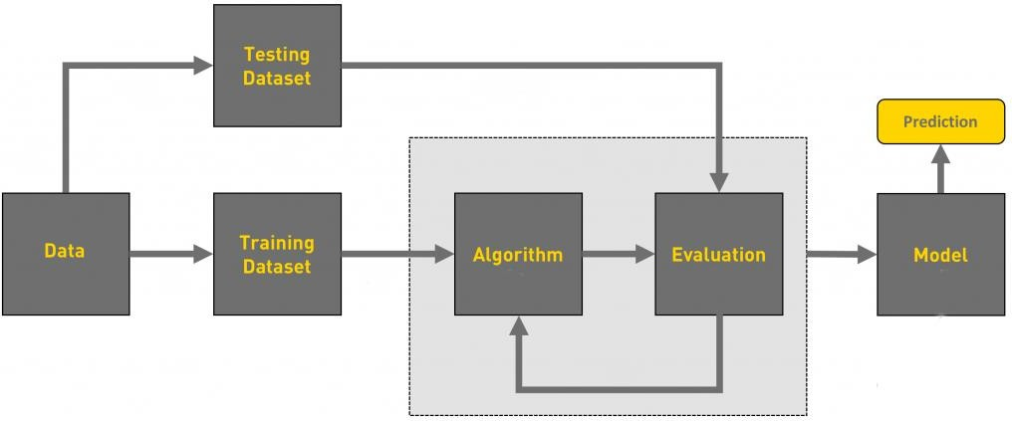

# REFERENCES:

1. [https://papers.nips.cc/paper/4824-imagenet-classification-with-deep-convolutional-neural- networks.pdf](https://papers.nips.cc/paper/4824-imagenet-classification-with-deep-convolutional-neural-networks.pdf)